Q1.Write a program in java to compare two strings

Test Data :

Check the length of two strings:

--------------------------------

Input the 1st string : aabbcc

Input the 2nd string : abcdef

String1: aabbcc

String2: abcdef

Expected Output : Strings are not equal.

Check the length of two strings:

--------------------------------

Input the 1st string : aabbcc

Input the 2nd string : aabbcc

String1: aabbcc

String2: aabbcc

Expected Output : Strings are equal.

import java.util.Scanner;

class T1{

public static void cmpString(String s1,String s2){

if(s1.equals(s2)){

System.out.println("String 1 and String 2 are equal");

}

else{

System.out.println("String 1 and String 2 are not equal");

}

}

public static void main(String args[]){

Scanner obj=new Scanner(System.in);

System.out.println("Enter String 1 : ");

String a=obj.nextLine();

System.out.println("Enter String 2 : ");

String b=obj.nextLine();

cmpString(a,b);

}

}

Q3. Write a program in java to count total number of alphabets, digits and

special characters in a string.

Test Data :

Input the string : Welcome to w3resource.com

Expected Output :

Number of Alphabets in the string is : 21

Number of Digits in the string is : 1

Number of Special characters in the string is : 3

import java.util.Scanner;

class T1{

public static void countAds(String s){

int alp=0,dig=0,sp=0;

for(int i=0;i<s.length();i++){

char c=s.charAt(i);

if(c>='A' && c<='Z'){

alp++;

}

if(c>='a' && c<='z'){

alp++;

}

if(c>='0'&& c<='9'){

dig++;

}

if(c==' ' || c=='.'){

sp++;

}

}

System.out.println("Alphabets : "+alp);

System.out.println("Digits : "+dig);

System.out.println("Special characters : "+sp);

}

public static void main(String args[]){

Scanner obj=new Scanner(System.in);

System.out.println("Enter String : ");

String a=obj.nextLine();

countAds(a);

}

}

Q3. Write a program in Java to count total number of vowel or consonant

in a string.

Test Data :

Input the string : Welcome to w3resource.com

Expected Output :

The total number of vowel in the string is : 9

The total number of consonant in the string is : 12

import java.util.Scanner;

class T1{

public static void countVowelAndConsonent(String s){

int v=0,cn=0;

for(int i=0;i<s.length();i++){

char c=s.charAt(i);

if(c=='a'||c=='i'||c=='u'||c=='o'||c=='e'||c=='A'||c=='I'||c=='U'||c=='O'||c=='E'){

v++;

}

else if(c>='0' && c<='9'||c==' '||c=='.'){

continue;

}

else{

cn++;

}

}

System.out.println("Vowels Are : "+v);

System.out.println("Consonent Are : "+cn);

}

public static void main(String args[]){

Scanner obj=new Scanner(System.in);

System.out.println("Enter String : ");

String a=obj.nextLine();

countVowelAndConsonent(a);

}

}

Q4. 4. Write a program in java to find maximum occurring character in a

string.

Test Data :

Input the string : Welcome to w3resource.com.

Expected Output :

The Highest frequency of character 'e'

appears number of times : 4

import java.util.Scanner;

class T1{ //welcome

public static void mostOccuringCharacter(String str1){

int ctr[] = new int[256];

int l = str1.length();

for (int i = 0; i < l; i++)

ctr[str1.charAt(i)]++;

int max = -1;

char result = ' ';

for (int i = 0; i < l; i++) {

if (max < ctr[str1.charAt(i)]) {

max = ctr[str1.charAt(i)];

result = str1.charAt(i);

}

}

System.out.println("Max occuring character : "+result);

}

public static void main(String args[]){

Scanner obj=new Scanner(System.in);

System.out.println("Enter String : ");

String a=obj.nextLine();

mostOccuringCharacter(a);

}

}

Q6. Write a java program to print most occurring digit from the given number.

Enter Any Number : 1221223

Most Occurring Digit is :2

import java.util.Scanner;

class T1{ //welcome

public static void mostOccuringCharacter(String str1){

int ctr[] = new int[256];

int l = str1.length();

for (int i = 0; i < l; i++)

ctr[str1.charAt(i)]++;

int max = -1;

char result = ' ';

for (int i = 0; i < l; i++) {

if (max < ctr[str1.charAt(i)]) {

max = ctr[str1.charAt(i)];

result = str1.charAt(i);

}

}

System.out.println("Max occuring digits : "+result);

}

public static void main(String args[]){

Scanner obj=new Scanner(System.in);

System.out.println("Enter String : ");

String a=obj.nextLine();

mostOccuringCharacter(a);

}

}

Q2. Write a java program to print unique digits from the given number

Enter Any Number : 1232351

Unique Digit is : 1

import java.util.Scanner;

class T1{

public static void printUniqeDigit(int n){//32123

int freq[]=new int[10];

while(n!=0){//0

int r=n%10;//3

freq[r]++;

n=n/10;

}

System.out.println("Unique Digis from the given number");

for(int i=0;i<freq.length;i++){

if(freq[i]==1){

System.out.print("\t"+i);

}

}

}

public static void main(String args[]){

Scanner obj=new Scanner(System.in);

System.out.println("Enter String : ");

int a=obj.nextInt();

printUniqeDigit(a);

}

}

Q2. Write a java program to print duplicate digits from the given number

Enter Any Number : 1232351

Duplicates Digit is : 2 3 1

import java.util.Scanner;

class T1{

public static void printUniqeDigit(int n){//32123

int freq[]=new int[10];

while(n!=0){//0

int r=n%10;//3

freq[r]++;

n=n/10;

}

System.out.println("duplicates Digits from the given number");

for(int i=0;i<freq.length;i++){

if(freq[i]>1){

System.out.print("\t"+i);

}

}

}

public static void main(String args[]){

Scanner obj=new Scanner(System.in);

System.out.println("Enter String : ");

int a=obj.nextInt();

printUniqeDigit(a);

}

}

Q1. Explain Access specifier in java programming?

Ans: Access specifier can specify the scope of member data, member function, class and interfaces

There are 4 access specifier in java programming

1. private: It can access only inside the class

Recommended for Member data

We cannot use private access specifier as a class level

1. public: It can access fro any where

Recommended for methods, constructors, classes and interfaces

1. protected: It can access inside the class or its child class

Recommended for Member data.

We can not uses protected access specifier as a class level

1. Default: It can accessible only inside the package

Example public and default access specifer with package

package indore;

import bhopal.A;

class B{

public static void main(String args[]){

A obj=new A();

System.out.println(obj.x);

}

}

package bhopal;

public class A{

public int x=10;

}

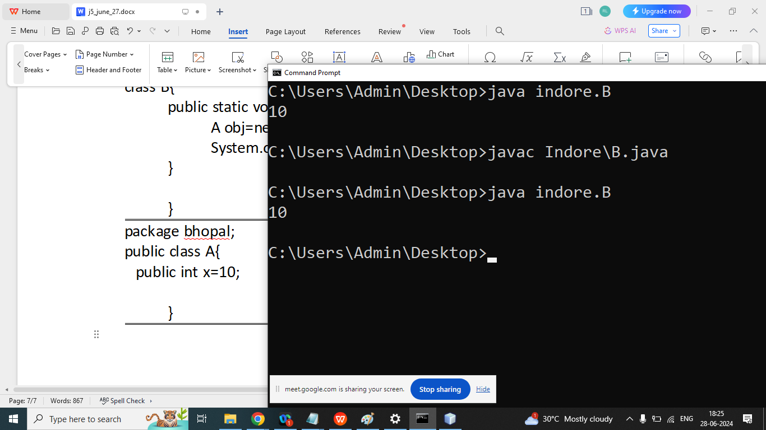

package indore;

public class A {

protected int x = 10;

}